**Registering for Training Websites**

**BP Better Training (bpbetter.com)** 1-888-274-3578 (1-888-BP-HELPU) and select options 3, 3, 4

Have employees use their personal emails

District Managers –

Use 91274397 as the jobbership’s partner number

BP Company Operated Store Managers –

Use the store’s SVB number

Non-BP Company Operated Stores –

Use SVB number 3758604

Download Instructions on how to register on BP Better

**Shell Retail Learning Portal (shellrlp.com)** Call Us @ 844.239.3993; Hours 8-5 (CST) M-F

Go to Account Management > Training Network Management

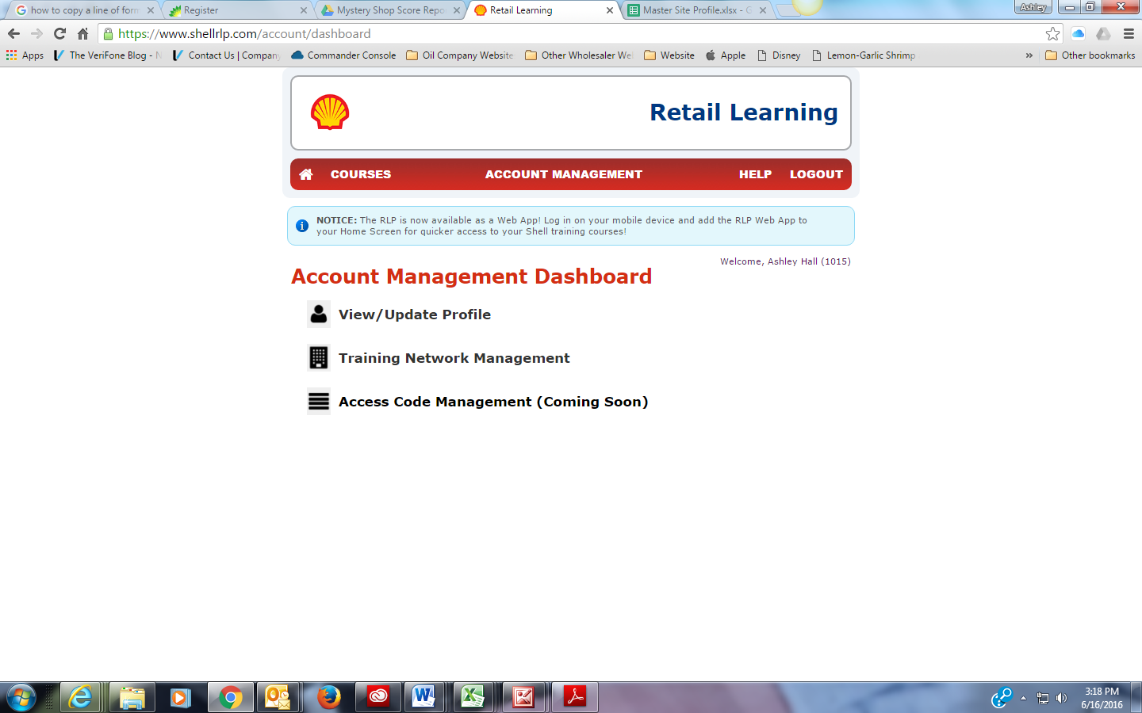

Make sure all of the locations that you manage are listed. If they are not listed, click ‘Add to your training network’ at the bottom of the page. If stores are listed that are not yours, click ‘Remove Stores from my training network’. Generate the access codes for the stores and employees that you as the site team lead manage.

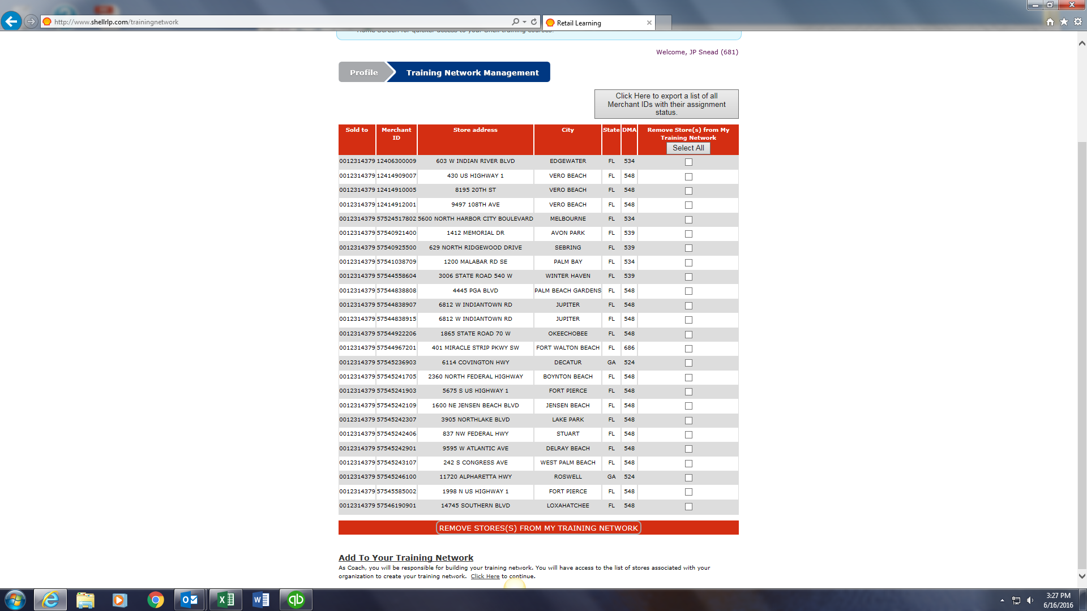

District Managers –

You should have received an access code from the Marketing Director. If not, request that another code is sent.

Shell Company Operated Stores –

The District Manager will need to follow steps above to generate an access code.

Non-Shell Company Operated Stores –

Give Store Managers the access code STL 57524521002

Store Managers should give their employees the access code 57524521002

**ExxonMobil Training Resource Center (emtrainingresourcecenter.com)**

District Managers Register as a “BW Employee”. Store Managers, Employees and Dealers will register as a “Site, Dealer employee”. The site number is a 6 digit number that should be found on your store receipts and on the Master Site Profile.

District Managers –

Use 106958 as the customer number

ExxonMobil Company Operated Store Managers –

Use the store’s Site/PBL number

Non-ExxonMobil Company Operated Stores –

Use Site/PBL number 311040