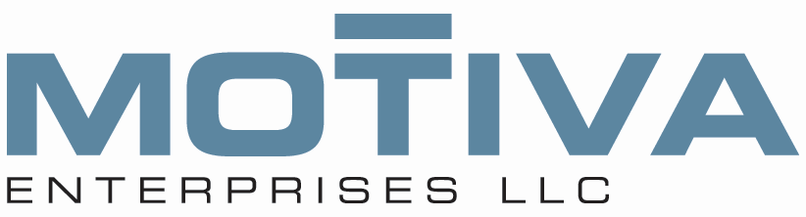

Thank you for your continued effort to gain more loyal customers at your site. As you are aware, Southeast Grocer has decided to end the fuelperks program. We have received notice that the last day to earn points at Winn Dixie and Bi-Lo is **March 26** and the last day to redeem points at Shell is **April 30.**

Given the potential volume loss at your sites, it is critical that we continue efforts to convert Winn Dixie and Bi-Lo customers to **FUEL REWARDS**. Our offer is compelling…and no groceries are required:

* 25 cents per gallon reward to join
* 10 cents per gallon savings on Shell V-Power Nitro+; the Best Total Engine Protection
* 5 cents per gallon savings on maingrade

We have enrolled many new Fuel Rewards members to the program in your area and we see that these new members are now buying more fuel and purchasing more from the convenience store….as much as 38% more fuel and 14% more from the convenience store.

Below is the new pump decal which will arrive at your sites on February 18 to post on February 20. In addition, we have purchased new billboards and radio ads to support your efforts and will continue investing in incentives for cashiers and site staff.

Please let us know if you need any additional information or support.

Thank you!



Example: New Pump Decal – Post on Feb 20th