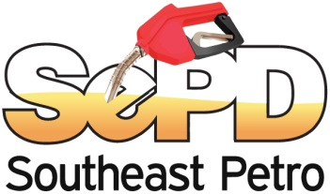
Southeast Petro Distributors, Inc.
402 High Point Dr. | Cocoa, FL 32926
Office: 321-632-0245 | Fax: 321-633-0467
Website: www.southeastpetro.com
ADA CALL FOR ASSISTANCE ORDER FORM
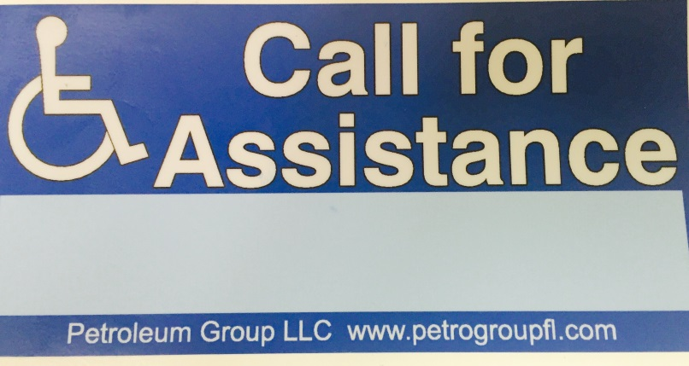
According to Florida Statute 526.141(b)1, all self-service gasoline stations must have the ADA Call for Assistance decal (pictured to the left) on each gas pump as of July 1st, 2016. The Department of Agriculture will cite a location that is not in compliance with the new law, giving 5 days to install the new decals.

Southeast Petro can provide these stickers to you at a cost of $3.00 per decal plus shipping. Fill out the order form below to have the decals shipped directly to your station. Billing will be handled through EFT.
Name: _____________________________________________________________
Station Name: _______________________________________________________
Station Address (Shipping Address): ______________________________________________________________________________________________________________________________________
_______ Number of Decals (Order one for each side of the pump)
Method of Shipment
_______ Standard Shipping (US Mail) ________ Expedite Overnight
By signing below, I understand that the cost of the decal is $3 each plus shipping, and will be drafted from my account. Shipping rates may vary depending on the method of shipment.
____________________________________________ _______________
Signature Date
Fax to 321-633-0467 Attention: Chirona

