Are You Prepared
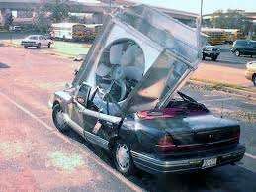
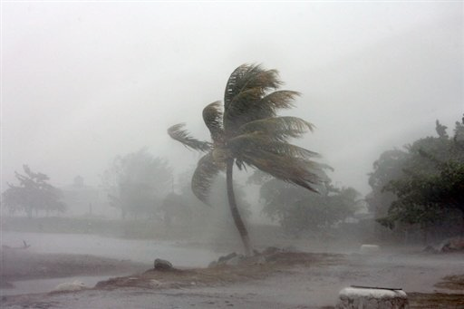
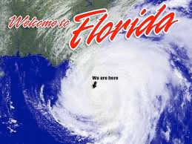
Hurricane Season 6-1 thru 11-30

Will your station be ready?

As June 1 approaches, we will see the start of the Hurricane Season. Predictions are for there to be 7 named storms this year, remember that is a prediction and how bad any one of them could be is anybody's guess.

Yes it is that time of year once again and we must take the time now to prepare. Waiting is NOT an option. Safety of our station personnel and equipment is very important to us, thus we ask that you take the time necessary to prepare.

We have provided some guidelines for your use.

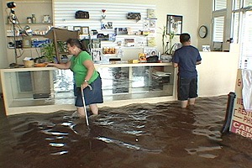

- Make a list of important phone numbers. have this list posted at the register and keep a copy with you. Send the list to your supervisor and the office.
Police and Hospitals
All store personnel with both home and cell numbers. A second contact would also be helpful.
Supervisors cell and home.
Vendors business and cell if you have them.
Security company phone number

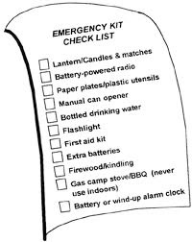

Just a note: with all the rain that we get you should be sticking your tanks more often. Be sure to use the ethanol paste we provided. Check that the lids and caps are on securely. You can put vaseline around the rim of the fill pipe lid this will help seal it and keep water from getting in.

- Prepare an emergency kit (a large plastic tote works well).
First Aid Kit
Portable, battery-powered radio with extra batteries
Flashlight with extra batteries
Wrench, pliers, screwdriver and other tools
Duct Tape and scissors
Plastic bags
Shrink wrap
Vaseline
Work gloves
Rain coat
Disposable camera
Hard hat
Safety vest
safety glasses
telephone (NOT a wireless one)
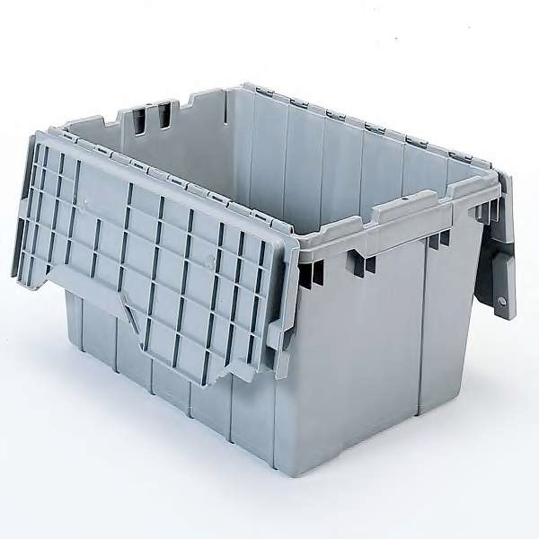
As the storm moves into your location you need to be ready. Do you know who can work? Do you know where the emergency kit is? Do you need to call your supervisor for directions on what to do next? Is you location being evacuated? Do you have a key to lock the front door if necessary?

ARE YOU PREPARED

Before closing a station down PLEASE contact your supervisor. If they are not answering then call one of the other supervisors.

IF YOU NEED TO CLOSE USE THIS CHECKLIST AS A GUIDE.

- Prepare a checklist (like the one below) to share with your employees on what to do if a storm is going to hit your area.
remove objects from the floor
bring trash cans into secured location
remove numbers from price sign
wrap pumps with shrink wrap
do a Day Close
open registers remove cash
remove Lottery scratch off tickets from display
secure all cash and lottery tickets
tape the windows and doors
unplug electrical equipment such as lotto machine, ruby, computer, pay-spot, ATM
cover all electrical equipment with trash bags
shut the pumps down at the electrical panel
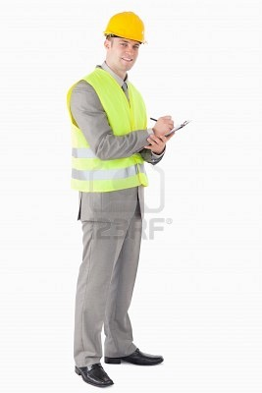

BACK TO WORK TIME TO REOPEN YOUR STATION
call your supervisor and let them know you are going back to open
call security and let them know you are opening
call staff in to help you do not know what you will find
look the property over, pumps, windows, roof, light poles, electrical and water lines
BE CAREFUL if you see something that is wrong call your supervisor, take pictures
once inside check out the station for damage of any tipe
remove plastic wrap from pumps, remove trash bags from equipment
stick the tanks you need to check to see if any water got into them
return scratch off games to display
return cash to register
thank your staff for their hard work both before and after the storm
OPEN the station
Let your supervisor know of any damage or problems that happened while the station was closed

